Power BI Capstone Project Report
ShopNest Store
by: Ambreen Hasan

Introduction
This report presents a comprehensive business analysis of the ShopNest retail dataset using Power BI. The objective of the dashboard is to analyze sales performance, delivery efficiency, customer behavior, product ratings, and revenue trends.

Q1: Top categories by Total Price
Statement: Identify and visually represent the top 10 product categories by total sales.
Power BI visualization
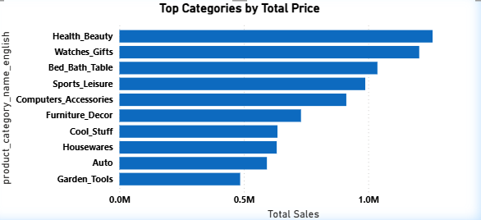
Explanation: The visualization displays the top 10 product categories ranked by total price.
Categories such as Health, bath, sports and computers contribute the highest sales, indicating strong demand in lifestyle related products.
This insight can support strategic decisions such as inventory planning, promotional focus, and supplier negotiations.

Q2: Delayed Orders Analysis
Statement: Determine the number of delayed orders in each category. An order is considered delayed if the actual delivery date is later than the estimated delivery date.

Power BI visualization
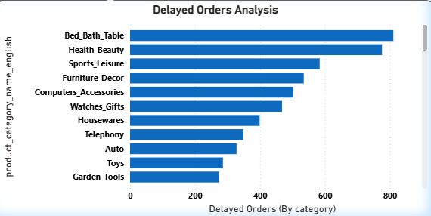
Explanation: Delayed orders were calculated by comparing the actual delivery date with the estimated delivery date. Orders where the delivered date exceeded the estimated date were classified as delayed.
A DAX measure was created to calculate delayed orders by comparing estimated delivery date and the actual delivery date.
The visualization displays the number of delayed orders across different product categories. The Analysis reveals that certain categories experience a higher number of delayed deliveries compared to others.
Findings: The main factors for delayed deliveries can be:
- Product type and handling complexity
- Supply location
- Inventory availability
- Shipping distance
This analysis helps identify operational inefficiencies and supports improvements in logistics management. This insight helps the business focus on improving delivery timelines and customer satisfaction.

Q3: Monthly comparison of delayed and on Time orders
Statement: Create a dynamic visual comparing delayed orders to on-time orders for each month. Utilize drillthrough to provide detailed delivery analysis.
Power BI Visualization
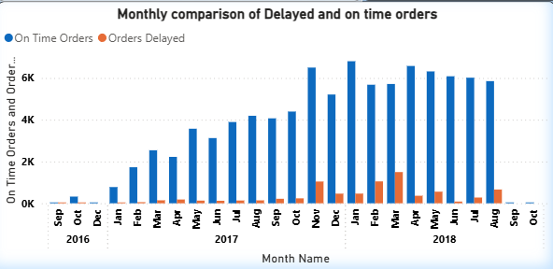
Explanation: The monthly comparison chart illustrates trends in on-time and delayed deliveries across different months and years.
Two DAX measures were created ‘On time orders’ and ‘Delayed orders’.
Findings: From trend analysis-
- On time orders consistently exceed delayed orders across months.
- Certain months show noticeable spikes in delayed deliveries which may indicate seasonal operational pressure.
- There is visible growth in total order volume over time suggesting business expansion
Using the drillthrough feature, detailed order-level data was examined. During analysis, it was observed that some orders marked as “On Time” had missing delivery dates, indicating possible data quality inconsistencies

Q4: Payment Method Analysis
Statement: Analyze the most frequently used payment methods by customers using appropriate visualization.
Power BI Visualization
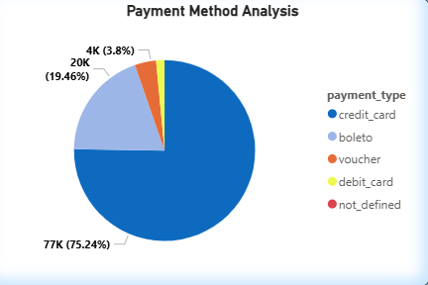
Explanation: A pie chart was created using the payment type. The values represent the distinct count of order ids associated with each payment method.
The payment method analysis shows that credit cards account for the majority of transactions, followed by boleto payments. Other payment methods such as vouchers and debit cards represent a smaller share.
The dominance of credit card transactions suggests strong customer preference for card-based payments. This insight can guide promotional offers, installment plans, and payment gateway optimizations.
Findings: This analysis helps the business-
- Understand customer payment preferences.
- Optimize payment gateway partnership.
- Implement installment-based sales strategies.
- Identify underutilized payment methods.

Q5: Product Rating Analysis
Statement: Determine the top 10 highest-rated products and the bottom 10 lowest-rated products using a bar or column chart.

Power BI Visualization
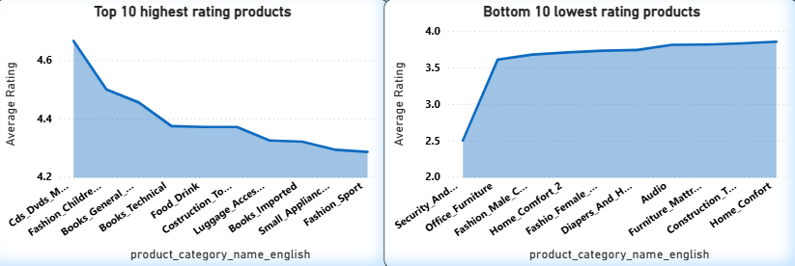
Explanation: The rating analysis evaluates customer satisfaction across products and categories using average review scores.
An average rating measure was created using the review_score field from the Order Reviews dataset. The measure calculates the average score for each product through the relationship chain between products, order items, orders, and reviews.
Findings: The Top 10 Highest-Rated Products visualization highlights products with the strongest customer satisfaction. These products consistently receive high review scores, typically close to 5.
The Bottom 10 Lowest-Rated Products visualization identifies products that receive comparatively lower ratings. These products may require:
- Quality improvement
- Better product descriptions
- Improved packaging
- Supplier evaluation

Q6: State wise sales analysis
Statement: Identify and visually represent states with high and low sales performance.
Power BI Visualization
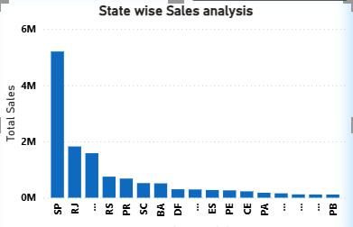
Explanation: This analysis evaluates revenue distribution across different states to understand regional sales performance.
Total revenue was calculated by summing the product price and freight value from the Order Items dataset. The visualization displays sales by customer state, allowing identification of high- and low-performing regions.
The results show that a few states contribute a significantly larger share of total revenue compared to others. This indicates concentrated market penetration in specific regions.
Findings: High-performing states represent strong customer demand and established market presence. Lower-performing states may indicate opportunities for:
- Targeted marketing campaigns
- Regional promotions
- Logistics optimization
- Market expansion strategies
Understanding geographic sales distribution enables more strategic allocation of marketing and operational resources.

Q7: Seasonal Sales Patterns (Quarterly)
Statement: Investigate and visualize seasonal patterns or quarterly trends in sales over time.
Power BI Visualization
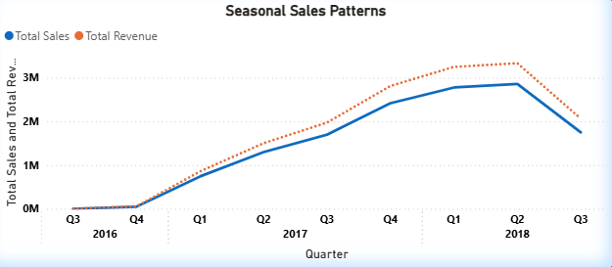
Explanation: This analysis evaluates seasonal and quarterly sales trends over time to identify patterns in revenue performance.
Total Sales was calculated using the sum of the product price whereas Total revenue was calculated using the sum of product price and freight value from the Order Items dataset. Sales were grouped by Year and Quarter using the Date table to ensure correct chronological aggregation.
The quarterly trend reveals a consistent upward growth pattern from 2016 to 2018, indicating strong business expansion. Sales increase steadily across most quarters, with noticeable peaks in certain periods.
Findings: In particular-
- Revenue shows significant growth from 2016 to 2017.
- 2018 demonstrates continued expansion, reaching the highest quarterly revenue levels.
- A slight drop in the final quarter may be attributed to partial-year data availability.
Certain quarters show stronger performance compared to others, suggesting seasonal buying behaviour. These fluctuations may be influenced by:
- Promotional campaigns
- Holiday seasons
- Consumer purchasing cycles
Understanding seasonal trends allows better forecasting, inventory planning, and marketing strategy alignment.

Q8: Revenue Analysis (Yearly)
Statement: Determine the total revenue generated by ShopNest and analyze how it changes over time on a yearly basis.
Power BI Visualization
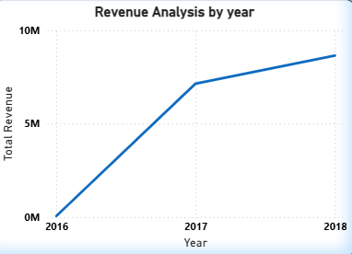
Explanation: This analysis evaluates total yearly revenue to understand overall business growth trends.
Revenue was calculated by summing both product price and freight value from the Order Items dataset, ensuring a complete representation of gross revenue generated by the store.
The yearly revenue trend shows a significant increase from 2016 to 2018. While 2016 reflects relatively low revenue due to partial-year data, 2017 demonstrates substantial growth, and 2018 records the highest overall revenue.
Findings: This steady upward trajectory indicates-
- Expansion of customer base
- Increased order volume
- Improved market penetration
- Strong operational scalability
The consistent growth pattern suggests that the business is successfully scaling over time.
Additionally, The Date table was used to aggregate revenue by year to ensure accurate chronological reporting. Using a consistent revenue definition (price + freight value) across both quarterly and yearly analysis maintains metric integrity throughout the dashboard.

Summary
- ShopNest demonstrates strong and consistent revenue growth from 2016 to 2018, indicating successful business expansion.
- Quarterly trends reveal identifiable seasonal patterns, with certain periods generating higher sales.
- Credit card payments dominate customer transactions, reflecting preference for convenient and installment-based payment options.
- Delivery performance is largely efficient, with most orders fulfilled on time, though some categories show higher delay rates requiring operational attention.
- Customer satisfaction remains consistently high, as reflected in strong average product ratings.
- Sales are concentrated in key states, presenting both strong regional performance and opportunities for further geographic expansion.
Overall, the analysis indicates a growing, stable, and customer-focused business with clear opportunities for operational and regional optimization.

